Bangladesh Medical Association (BMA)
List of Life Member-212
50. BMA Pabna Branch

Sl No | Voter No | Voter Details
1 | Voter No  LM-5000001 | DR. TAHSIN BEGUM  F/Name: Md. Idris Haider  M/Name:  BM & DC Reg. No:  NID:  Cell:  Address: Azeez Monzil  Gopalpur  Pabna  Blood Group:
2 | Voter No  LM-5000002 | DR. NIKHIL KUMAR SAHA  F/Name: Brindro Chandro Saha  M/Name:  BM & DC Reg. No:  NID:  Cell:  Address: M. O.  Mental Hospital  Pabna  Blood Group:
3 | Voter No  LM-5000003  No Image | DR. MD. MASUDUR RAHMAN  F/Name:  M/Name:  BM & DC Reg. No:  NID:  Cell:  Address: Transfered to BMA chudanga Branch  Blood Group:  TRANSFERED to BMA Dhaka City  LM-1405543
4 | Voter No  LM-5000004  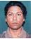 | DR. MD. ASLAM HOSSAIN BISWAS  F/Name: Md. Abul Quassem Biswas  M/Name:  BM & DC Reg. No:  NID:  Cell:  Address: Asst. Surgon  Eye Hospital  Pabna  Blood Group:
5 | Voter No  LM-5000005  No Image | DR. MD. AMINUL HASAN PALASH  F/Name: Late Nefaz Uddin  M/Name:  BM & DC Reg. No:  NID:  Cell:  Address: M. O.  Mental Hospital  Pabna  Blood Group:
6 | Voter No  LM-5000006  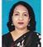 | DR. DILWARA AKHTER  F/Name: Md. Khorshed Alam  M/Name:  BM & DC Reg. No:  NID:  Cell:  Address: Clinical Asst.  Mental Hospital  Pabna  Blood Group:
7 | Voter No  LM-5000007  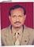 | DR. MD. ZILLUR RAHMAN  F/Name: Late Abdul Quddus Pk.  M/Name:  BM & DC Reg. No:  NID:  Cell:  Address: M. O.  General Hospital  Pabna  Blood Group:
8 | Voter No  LM-5000008 | DR. MD. ABDUR RAZZAQUE  F/Name: Md. Moused Ali  M/Name:  BM & DC Reg. No:  NID:  Cell:  Address: M. O.  Police Hospital  Pabna  Blood Group:
9 | Voter No  LM-5000009  No Image | DR. K. M. SOFIUL ALAM BADSHA  F/Name:  M/Name:  BM & DC Reg. No:  NID:  Cell:  Address: Transfered to BMA Dhaka City  LM-1402091.  Blood Group:  TRANSFERED to BMA Dhaka City  LM-1405543
10 | Voter No  LM-5000010  No Image | DR. KAMAL OSMAN  F/Name: Md. Belayet Hossain  M/Name:  BM & DC Reg. No:  NID:  Cell:  Address: THC Isurdi,  Pabna.  Blood Group:
11 | Voter No  LM-5000011 | DR. K. M. ABU ZAFOR  F/Name: Late Alhaz Md. Darbar Ali Khan  M/Name:  BM & DC Reg. No:  NID:  Cell:  Address: M. O.  Civil Surgon Office  Pabna  Blood Group:
12 | Voter No  LM-5000012  No Image | DR. QUAZI QUAMRUZZAMAN  F/Name: Late Quazi Naimuddin  M/Name:  BM & DC Reg. No:  NID:  Cell:  Address: Apt. H3, Ramna Apt  Magbazar  Dhaka  Blood Group:
13 | Voter No  LM-5000013  No Image | DR. MIZANUR RAHMAN  F/Name:  M/Name:  BM & DC Reg. No:  NID:  Cell:  Address: Transferd to BMA Sirajgonj Branch LM-62..  Blood Group:  TRANSFERED to BMA Dhaka City  LM-1405543
14 | Voter No  LM-5000014 | DR. MD. MANSUR RAHMAN  F/Name: Late Md. Mofer Ali Sarder  M/Name:  BM & DC Reg. No:  NID:  Cell:  Address: Dakbangla Market  Isurdi  Pabna  Blood Group:
15 | Voter No  LM-5000015  No Image | DR. MD. BADIUZZAMAN  F/Name:  M/Name:  BM & DC Reg. No:  NID:  Cell:  Address: TRANSFERED to BMA Rajshahi Branch  Blood Group:  TRANSFERED to BMA Dhaka City  LM-1405543
16 | Voter No  LM-5000016 | DR. MD. AMIRUL ISLAM  F/Name: Late Nurul Islam  M/Name:  BM & DC Reg. No:  NID:  Cell:  Address: Eye Hospital  Pabna  Blood Group:
17 | Voter No  LM-5000017 | DR. AMIN AHMED KHAN  F/Name: Md. Aminur Rahman Khan  M/Name:  BM & DC Reg. No:  NID:  Cell:  Address: M. O.  School Health Clinic  Pabna  Blood Group:
18 | Voter No  LM-5000018  No Image | DR. A.K.M. FAZLUL HAQUE  F/Name: Late Nadir Hossain  M/Name:  BM & DC Reg. No:  NID:  Cell:  Address: Reg. Medical Officer Atghoria UHC, Pabna.  Blood Group:
19 | Voter No  LM-5000019  No Image | DR. IFTEKHAR MAHMOOD  F/Name:  M/Name:  BM & DC Reg. No:  NID:  Cell:  Address: Principal, Kushtia Medical College, Kushtia.  Blood Group: B-  TRANSFERED to BMA Dhaka City  LM-1405543
20 | Voter No  LM-5000020  No Image | DR. A. K. M. FAZLUL HUQ  F/Name:  M/Name:  BM & DC Reg. No:  NID:  Cell:  Address: TRANSFERED to BMA Dhaka City  LM-1401857  Blood Group:  TRANSFERED to BMA Dhaka City  LM-1405543
21 | Voter No  LM-5000021  No Image | DR. MD. ALTAF HOSSAIN MONDOL  F/Name:  M/Name:  BM & DC Reg. No:  NID:  Cell:  Address: Clinical Asst. Mental Hospital, Pabna.  Blood Group:  TRANSFERED to BMA Dhaka City  LM-1405543
22 | Voter No  LM-5000022  No Image | DR. MD. SABBIR RAHMAN  F/Name: Md. Golzar Hossain  M/Name:  BM & DC Reg. No:  NID:  Cell:  Address: Sr. Consultant  Mental Hospital  Pabna  Blood Group:
23 | Voter No  LM-5000023 | DR. MD. KHALILUR RAHMAN  F/Name: Late Montar Uddin Fakir  M/Name:  BM & DC Reg. No:  NID:  Cell:  Address: Jr. Consultant  TB Clinic  Pabna  Blood Group:
24 | Voter No  LM-5000024 | DR. DIPOK KUMAR GHOSH  F/Name: Kshitish Chandra Ghosh  M/Name:  BM & DC Reg. No:  NID:  Cell:  Address: M.O. TB Hospital Pabna  Blood Group:
25 | Voter No  LM-5000025  No Image | DR. MD. SALEMIR HOSSAIN CHOWDHURY  F/Name:  M/Name:  BM & DC Reg. No:  NID:  Cell:  Address: TRANSFERED to BMA Khulna Br.  Blood Group:  TRANSFERED to BMA Dhaka City  LM-1405543
26 | Voter No  LM-5000026 | DR. DILRUBA SIDDIQUE  F/Name: Abu Bakar Siddique  M/Name:  BM & DC Reg. No:  NID:  Cell:  Address: General Hospital  Pabna  Blood Group:
27 | Voter No  LM-5000027 | DR. HASANAT JAHAN  F/Name: Late Md.moktal Hussain  M/Name:  BM & DC Reg. No:  NID:  Cell:  Address: Hamida Villa  Gopalpur  Pabna  Blood Group:
28 | Voter No  LM-5000028  No Image | DR. MD. ABDUS SATTAR MIAH  F/Name: Late Jamir Uddin  M/Name:  BM & DC Reg. No:  NID:  Cell:  Address: Pathologist  General Hospital  Pabna  Blood Group:
29 | Voter No  LM-5000029  No Image | DR. SHYAMAL KUMAR BASAK  F/Name: Shashadhar Chandra Basak  M/Name:  BM & DC Reg. No:  NID:  Cell:  Address: Consultant Anaesthesiology  General Hospital  Pabna  Blood Group:
30 | Voter No  LM-5000030  No Image | DR. MD. SHAMSUDDIN MONDOL  F/Name:  M/Name:  BM & DC Reg. No:  NID:  Cell:  Address: : Late Monir Uddin Mondol  Blood Group:  TRANSFERED to BMA Dhaka City  LM-1405543
31 | Voter No  LM-5000031 | DR. S M MOSTAFIZUR RAHMAN  F/Name: Md. Afsar Uddin Shaikh  M/Name:  BM & DC Reg. No:  NID:  Cell:  Address: Civil Surgon Office  Pabna  Blood Group:
32 | Voter No  LM-5000032  No Image | DR. MD. SHAMSUL HAQUE  F/Name: Late Ahsan Ali Mollah  M/Name:  BM & DC Reg. No:  NID:  Cell:  Address: Consultant Anaesthesiology  General Hospital  Pabna  Blood Group:
33 | Voter No  LM-5000033 | DR. ABDUL BATEN MOLLAH  F/Name: Md. Montaz Uddin Mollah  M/Name:  BM & DC Reg. No:  NID:  Cell:  Address: Radiologist  General Hospital  Pabna  Blood Group:
34 | Voter No  LM-5000034 | DR. MD. REAZUL HAQUE  F/Name: Late Sadar Uddin  M/Name:  BM & DC Reg. No:  NID:  Cell:  Address: Sr. Consultant, Ortho surgery  General Hospital  Pabna  Blood Group:
35 | Voter No  LM-5000035 | DR. HASINA WAHAB  F/Name: Late Abdul Kadar Sarkar  M/Name:  BM & DC Reg. No:  NID:  Cell:  Address: Daizy Lodge  Naraynpur  Pabna  Blood Group:
36 | Voter No  LM-5000036  No Image | DR. MD. ABDUS SATTAR  F/Name: Md. Asmatullah PK  M/Name:  BM & DC Reg. No:  NID:  Cell:  Address: M. O.  General Hospital  Pabna  Blood Group:
37 | Voter No  LM-5000037 | DR. MD. NURUZZAMAN HAQUE  F/Name: Late Amin Uddin Ahmed  M/Name:  BM & DC Reg. No:  NID:  Cell:  Address: M. O.  General Hospital  Pabna  Blood Group:
38 | Voter No  LM-5000038  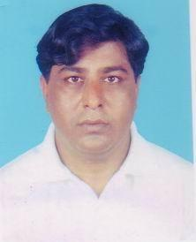 | DR. ABDUR RAHMAN  F/Name: Ayez Uddin Pramanik  M/Name:  BM & DC Reg. No:  NID:  Cell:  Address: Pabna Diagonostic Complex  Salgaria  Pabna  Blood Group:
39 | Voter No  LM-5000039  No Image | DR. MD. MONSUR ELAHI  F/Name:  M/Name:  BM & DC Reg. No:  NID:  Cell:  Address: TRANSFERED to BMA Natore Br.  LM-26  Blood Group:  TRANSFERED to BMA Dhaka City  LM-1405543
40 | Voter No  LM-5000040 | DR. MIRZA MD. MOAZZEM HOSSAIN  F/Name: Mirza Amzad Hossain  M/Name:  BM & DC Reg. No:  NID:  Cell:  Address: M. O., MCH FP, UHFPWC  Sador  Pabna  Blood Group:
41 | Voter No  LM-5000041 | DR. MD. NAZMUL AHSAN  F/Name: Md. Abdus Sattar  M/Name:  BM & DC Reg. No:  NID:  Cell:  Address: Salgaria  Pabna  Blood Group:
42 | Voter No  LM-5000042  No Image | DR. SAYED HASAN  F/Name: : Late Fazlur Rahman  M/Name:  BM & DC Reg. No:  NID:  Cell:  Address: Pabna Eye Hospital  Pabna  Blood Group:
43 | Voter No  LM-5000043 | DR. MD. SHAH ALAM  F/Name: Md. Abdul Hamid  M/Name:  BM & DC Reg. No:  NID:  Cell:  Address: M.O.  Seba Hospital  Pabna  Blood Group:
44 | Voter No  LM-5000044  No Image | DR. MD. TOSLIMUL AREFIN  F/Name: Md. Abdul Latif Miah  M/Name:  BM & DC Reg. No:  NID:  Cell:  Address: Chalk Pail Anpur  Pabna Sador  Pabna  Blood Group:
45 | Voter No  LM-5000045  No Image | DR. MONIR UDDIN AHMED  F/Name: Md. Abdus Sattar  M/Name:  BM & DC Reg. No:  NID:  Cell:  Address: Zalil Hazi Road  Shibrampur  Pabna  Blood Group:
46 | Voter No  LM-5000046  No Image | DR. MD. MOSTOFA KAMAL SELIM  F/Name: Md. Aminul Islam  M/Name:  BM & DC Reg. No:  NID:  Cell:  Address:  Blood Group:  E X P I R E D
47 | Voter No  LM-5000047  No Image | DR. A. K. M. ZIAZUL ISLAM  F/Name: A. K. M. Abdul Gaffar Miah  M/Name:  BM & DC Reg. No:  NID:  Cell:  Address: Shalgaria, Pabna.  Blood Group:
48 | Voter No  LM-5000048  No Image | DR. MD. MOMINUL ALAM  F/Name: Late Dabir Uddin Ahmed  M/Name:  BM & DC Reg. No:  NID:  Cell:  Address: Asst. Register  General Hospital  Pabna  Blood Group:
49 | Voter No  LM-5000049  No Image | DR. MRS ISMAT ARA BEGUM  F/Name: A. K. M. Abdul Gaffar Miah  M/Name:  BM & DC Reg. No:  NID:  Cell:  Address: MR Clinic  General Hospital  Pabna  Blood Group:
50 | Voter No  LM-5000050  No Image | DR. MD. ABDUL KHALEQUE  F/Name: Md. Abul Kashem  M/Name:  BM & DC Reg. No:  NID:  Cell:  Address: Chalk Pail Anpur  Pabna  Blood Group:
51 | Voter No  LM-5000051  No Image | DR. K A B AMINUZZAMAN CHOWDHURY  F/Name: Khaza Aktaruzzaman Chowdhury  M/Name:  BM & DC Reg. No:  NID:  Cell:  Address: Dilal pur , Chowdhury Bari  Pabna  Blood Group:
52 | Voter No  LM-5000052 | DR. MAZURA RAHMAN  F/Name: Manzura Rahman  M/Name:  BM & DC Reg. No:  NID:  Cell:  Address: Ataikula Road  Shalgaria  Pabna  Blood Group:
53 | Voter No  LM-5000053 | DR. DILARA BEGUM  F/Name: Abdur Rahman  M/Name:  BM & DC Reg. No:  NID:  Cell:  Address: Poilanpur  Pabna  Blood Group:
54 | Voter No  LM-5000054 | DR. FAWZIA BEGUM  F/Name: Md. Ekramul Haque  M/Name:  BM & DC Reg. No:  NID:  Cell:  Address: Maternal & Child welfare Centre  Gobinda  Pabna  Blood Group:
55 | Voter No  LM-5000055 | DR. MD. GULZAR HOSSAIN  F/Name: Late Md. Gulmahmud Paramanik  M/Name:  BM & DC Reg. No:  NID:  Cell:  Address: Chatmohor Zero Point  Chatmohor  Pabna  Blood Group:
56 | Voter No  LM-5000056  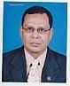 | DR. CAP. (RET,) SARWAR JAHAN FAIZ  F/Name: A.j.m. Faizuddin  M/Name:  BM & DC Reg. No: 6297  NID:  Cell:  Address: Senior Consultant, Skin & VD Department, General Hospital, Pabna  Blood Group:
57 | Voter No  LM-5000057 | DR. NARGIS SULTANA  F/Name: Md. Ruhul Amin  M/Name: Rawshan Ara  BM & DC Reg. No: 21595  NID:  Cell: 01199115359  Address: Doctors Quarter General Hospital, Pabna  Blood Group: B+
58 | Voter No  LM-5000058  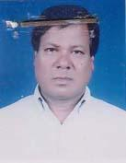 | MD. SAIEEF UDDIN YEAHIA  F/Name: Late. Abdul Latif Molla  M/Name: Late. Sabida Khatun  BM & DC Reg. No: 14721  NID: 7625507149669  Cell: 01199373050  Address: Hospital Road, Salgaria, Pabna  Blood Group: O+
59 | Voter No  LM-5000059 | DR. SHAHIN FERDOUS  F/Name: Md. Amjad Hossain  M/Name: Mrs. Jannatul Ferdous  BM & DC Reg. No: 18609  NID: 7625502116538  Cell: 01711117179  Address: House: Neerjhar, Lahiripara, Gopalpur, Pabna  Blood Group: B+
60 | Voter No  LM-5000060 | DR. ABU MOHD. SHAFIQUL HASAN  F/Name: Late. Abdul Wahed  M/Name: Anjuman Ara Begum  BM & DC Reg. No: 22847  NID: 7625501112016  Cell:  Address: U.H.C, Atgharia, Pabna  Blood Group: O+
61 | Voter No  LM-5000061 | DR. MD. SAIDUL ISLAM  F/Name: Md. Abu Bakar Mia  M/Name: Monowara Begum  BM & DC Reg. No: 20459  NID: 7623901502757  Cell: 01711177759  Address: Diabetic Hospital, Abdul Hamid Road, Pabna,  Blood Group:
62 | Voter No  LM-5000062 | DR. RAMDULAL BHOWMICK  F/Name: Radharaman Bhowmick  M/Name: Archana Bhowmick  BM & DC Reg. No: 12078  NID: 7625502120501  Cell: 01712546713  Address: Mahtab Monzil (2nd Floor), Ataikula Road, Nimtola, Pabna-6600  Blood Group: B+
63 | Voter No  LM-5000063 | DR. MD.SHAH NEWAZ  F/Name: Md. Abdul Latif  M/Name:  BM & DC Reg. No:  NID:  Cell:  Address: Senior Consultant, Skin And V.D Department, General Hospital Pabna.  Blood Group:
64 | Voter No  LM-5000064 | DR. MOST. HALIMA KHANOM  F/Name: Md. Hossain Ali  M/Name: Mrs. Rashida Ali  BM & DC Reg. No: 37478  NID: 7623306703746  Cell: 01729307201  Address: Upazilla Health Complex, Bhangoora, Pabna  Blood Group: A+
65 | Voter No  LM-5000065  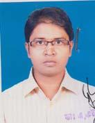 | DR. HUMAYUN KABIR KALLOL  F/Name: Md. Amin Uddin  M/Name: Mrs. Hamida Khanam  BM & DC Reg. No: 45623  NID: 2696406681236  Cell: 01823294842  Address: 250 Bedded General Hospital, Pabna  Blood Group: A+
66 | Voter No  LM-5000066  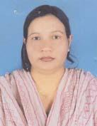 | DR. MST. FATEMA KHATUN  F/Name: Md, Altaf Hossain  M/Name: Taslima Begum  BM & DC Reg. No: 39665  NID: 2696352220276  Cell: 01712631973  Address: 4th Floor, PDC Hospital, Godaun More, Hospital Road, Pabna  Blood Group: B+
67 | Voter No  LM-5000067 | DR. NITISH KUMAR KUNDU  F/Name: Nikunja Behari Kundu  M/Name: Era Rani Kundu  BM & DC Reg. No: 22168  NID: 8198506406315  Cell: 01716508905  Address: Asst. Prof. Pabna Medical College, Pabna  Blood Group: A+
68 | Voter No  LM-5000068  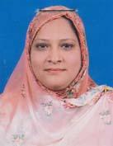 | DR. F. A. ASMA KHAN  F/Name: Late. Md. Gholum Hossain Khan  M/Name: Mrs. Shelina Khanom  BM & DC Reg. No: 23418  NID: 7623903511541  Cell: 01711366227  Address: C/O: Dr. Hassanuzzaman, Pearakhali, Ishwardi, Pabna  Blood Group: B-
69 | Voter No  LM-5000069 | DR. MD. HARUN-OR-RASHID  F/Name: Late. Hassen Ali  M/Name: Most. Amena Khatun  BM & DC Reg. No: 20005  NID: 25502121604  Cell: 01712609526  Address: Upazilla Health & F.P Officer, Pabna Sadar, Pabna  Blood Group: B+
70 | Voter No  LM-5000070 | DR. MONIKA MEHJABIN  F/Name: M.A Mannan  M/Name: Mrs. Ruma Mannan  BM & DC Reg. No: 53044  NID: 1022007064389  Cell: 01712278154  Address: Kacharipara, Kadamtola, Pabna  Blood Group: A+
71 | Voter No  LM-5000071 | DR. MD. ROKIB SADI  F/Name: Md. Bodruddoza Sadi  M/Name: Mst. Gulsanara Begum  BM & DC Reg. No: 48187  NID: 8198510365092  Cell: 01717496584  Address: Vill: Shalgaria, Post: Pabna, Dist: Pabna  Blood Group: O+
72 | Voter No  LM-5000072 | DR. JAHEDI HASAN RUMI  F/Name: Md. Wazed Ali Shaikh  M/Name: Anowara Begum  BM & DC Reg. No: 33754  NID: 7618357302806  Cell: 01716163162  Address: Assistant Registrar, Ortho Surgery, Pabna General Hospital  Blood Group: A+
73 | Voter No  LM-5000073 | DR. MD. MAHBUBUL ALAM  F/Name: Md. Khorshed Alam  M/Name: Most. Jebunnessa Begum  BM & DC Reg. No: 17865  NID: 7625501112561  Cell: 01712502980  Address: Pabna Diagnostic Centre, Hospital Road, Shalgaria, Pabna  Blood Group: O+
74 | Voter No  LM-5000074 | DR. MD. MAHFUZUL ALAM  F/Name: Md. Zahangir Alam  M/Name: Mrs. Marium Alam  BM & DC Reg. No: 45590  NID: 2699039534772  Cell: 01720839973  Address: 604/15 Weat Shalgaria, Hospital Road, Pabna Sadar, Pabna  Blood Group: AB_po
75 | Voter No  LM-5000075 | DR. MD. SABIZUR RAHMAN  F/Name: A. K. M. Fazlul Haque  M/Name: Gulshan Ara Begum  BM & DC Reg. No: 28343  NID: 7622205983167  Cell: 01711440452  Address: Upazilla Health Complex, Chatmohar, Pabna  Blood Group: A+
76 | Voter No  LM-5000076 | DR. MOST. RUBINA PARVIN SULTANA  F/Name: Md. Robiul Alam Lohani  M/Name: Sahajadi Begum  BM & DC Reg. No: 49276  NID: 19833218213000019  Cell: 01712539109  Address: Doctors Quarter, UHC, Atgharia, Pabna  Blood Group:
77 | Voter No  LM-5000077 | DR. M. M. ZAHIDUL ISLAM  F/Name: Md. Yousuf Ali  M/Name: Mrs. Zohura Begum  BM & DC Reg. No: 47540  NID: 5728708125009  Cell: 01191417397  Address: Ataikula Road (Alhaj Math), Pabna Sadar, Pabna  Blood Group: O+
78 | Voter No  LM-5000078  No Image | DR. MD MASUD KARIM  F/Name:  M/Name:  BM & DC Reg. No: A-33360  NID:  Cell:  Address: Hatikhara Saidpur Ni  Blood Group:  TRANSFERED to BMA Dhaka City  LM-1405543
79 | Voter No  LM-5000079 | DR. MD. ATIQUR RAHMAN  F/Name: Md. Rostom Ali Khan  M/Name: Late. Farida Khatom  BM & DC Reg. No: 28007  NID: 7617260498517  Cell: 01711174212  Address: Vill & PO: Kashinathpur, PS: Santhia, Dist: Pabna, Bangladesh  Blood Group: B+
80 | Voter No  LM-5000080  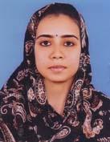 | DR. RAHIMA KHATUN  F/Name: Md. Abdul Jalil  M/Name: Safura Jalil  BM & DC Reg. No: 51182  NID: 2697556370691  Cell: 01746177339  Address: UHC, Santhia, Pabna  Blood Group:
81 | Voter No  LM-5000081 | DR. SIPON KUMAR DAS  F/Name: Ranendra Nath Das  M/Name: Jharna Rani Das  BM & DC Reg. No: 49825  NID: 7627205382910  Cell: 01712022786  Address: Vill: Santhia Bazar, Post: Santhia, Thana: Santhia, Dist: Pabna  Blood Group: B+
82 | Voter No  LM-5000082  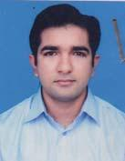 | DR. MD. RAKIBUL KARIM  F/Name: Abdus Sattar Sikdar  M/Name: Sultana Rasheda  BM & DC Reg. No: 46040  NID: 7625504134363  Cell: 01717429748  Address: Al-Amin, Vill: South Raghabpur, Thana: Pabna Sadar, Dist: Pabna  Blood Group: O+
83 | Voter No  LM-5000083 | DR. AZMIRI BEGUM  F/Name: Sheikh Harunar Rashid  M/Name: Halima Begum  BM & DC Reg. No: 12910  NID:  Cell: 01715507788  Address: Upazilla Health Complex, Ishwardi, Pabna  Blood Group: B+
84 | Voter No  LM-5000084  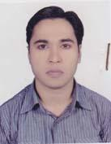 | DR. MD. ABDUS SUKUR  F/Name: Late. Minhaz Fakir  M/Name: Most. Chondrabanu  BM & DC Reg. No: 49969  NID: 7627204611478  Cell: 01816-216621  Address: Vill: South Boalmari, PO & PS: Santhia, Dist: Pabna  Blood Group: B+
85 | Voter No  LM-5000085 | DR. SHARMIN SHABNAM  F/Name: Abdul Matin  M/Name: Nilufar Yesmin  BM & DC Reg. No: 51828  NID: 2695435978469  Cell: 01820975379  Address: Govinda Dewan Bari Masjid, Govinda, Pabna  Blood Group: O+
86 | Voter No  LM-5000086 | DR. IKRAMUNNAHAR  F/Name: Late. Rajab Ali  M/Name: Shamsunnahar  BM & DC Reg. No: 21801  NID: 7621906625140  Cell: 01718027381  Address: Medical Officer, UHC, Vangura, Pabna  Blood Group: A+
87 | Voter No  LM-5000087 | DR. MAHMUDUR RASHID  F/Name: Md. Rais Uddin  M/Name: Mrs. Monowara Begum  BM & DC Reg. No: 53152  NID: 7625505142058  Cell: 01717486071  Address: Hazra Malakar By Len (Shamoly Garez), Shalgharia, Pabna  Blood Group: O+
88 | Voter No  LM-5000088  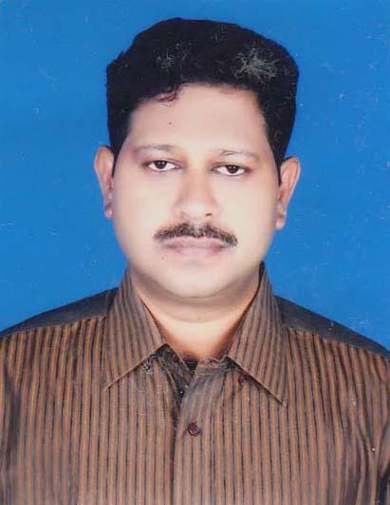 | DR. ABDULLAH AL MAMUN  F/Name: Md. Abdul Mannan  M/Name: Mrs. Mahmuda Khatun  BM & DC Reg. No: 29537  NID:  Cell: 01711954888  Address: Gopalpur EB Road, Pabna  Blood Group: B+
89 | Voter No  LM-5000089 | DR. MOHAMMAD SALIM MORSHED  F/Name: Mohammad Abdul Halim  M/Name: Howwa Begum  BM & DC Reg. No: 30699  NID: 7628306189425  Cell: 01711073450  Address: UHC, Sujanagar, Pabna  Blood Group: O+
90 | Voter No  LM-5000090 | DR. MD. MASUDUR RAHMAN  F/Name: Md. Badiur Rahman  M/Name: Mrs. Jahanara Begum  BM & DC Reg. No: 27683  NID: 2694811029788  Cell: 01711786789  Address: Asst. Professor (CC) (Ortho Surgery Dept.), Pabna Medical College  Blood Group: B+
91 | Voter No  LM-5000091 | DR. MUHAMMAD SHAHADOT HOSSAIN  F/Name: Alhaj Md. Baher Uddin  M/Name: Amina Khatun  BM & DC Reg. No: 15115  NID: 7621906624780  Cell: 01711451153  Address: UH & FPO, UHC, Bhangoora, Pabna  Blood Group: B+
92 | Voter No  LM-5000092 | DR. ENAMUL KARIM  F/Name: Dr. M.A Goni  M/Name: Sahera Banu  BM & DC Reg. No: 14483  NID:  Cell: 01712021651  Address: Jr. Consultant (oph), General Hospital, Pabna  Blood Group: A+
93 | Voter No  LM-5000093 | DR. HOSSAIN MD. ZULFIQUER ALI (ARIF)  F/Name: Md. Tofazzal Hossain  M/Name: Mst. Mahzebin Ara  BM & DC Reg. No: 42455  NID: 8198501980381  Cell: 01716204962  Address: Assistant Registrar, Cardiology, General Hospital, Pabna  Blood Group: O+
94 | Voter No  LM-5000094 | DR. MD. MOZAFFOR HOSSAIN  F/Name: Late. Sayed Ali Miah  M/Name: Late. Ayesha Khatun  BM & DC Reg. No: 22246  NID: 4917971375246  Cell: 01925994361  Address: UHC, Santhia, Pabna  Blood Group: AB_po
95 | Voter No  LM-5000095 | DR. KAZI NAHIDA AKHTER LIPI  F/Name: Kazi Abdul Barik  M/Name: Mahmuda Bari  BM & DC Reg. No: 33755  NID: 7618357302802  Cell: 01711706606  Address: Mitu General Hospital, Pabna  Blood Group: A+
96 | Voter No  LM-5000096  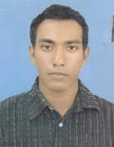 | DR. MD. HABIBUL HAQUE  F/Name: Md. Ismail Hossain Miah  M/Name: Saleha Khanam  BM & DC Reg. No: 52020  NID: 0695111189884  Cell: 01710450535  Address: 250 Bedded General Hospital, Pabna  Blood Group: B+
97 | Voter No  LM-5000097 | DR. MD. MOTAHAR HOSSAIN  F/Name: Moazzem Hossain  M/Name: Sajeda Khatoon  BM & DC Reg. No: 20919  NID: 2699040675489  Cell: 01819991820  Address: Pabna Medical College & Hospital, Pabna  Blood Group: O+
98 | Voter No  LM-5000098 | DR. GALIBA TASNIM  F/Name: Md. Abdul Gani Mia  M/Name: Mst. Saleha Begum  BM & DC Reg. No: 52129  NID: 8198510364324  Cell: 01716052629  Address: Khan Nibas, Holding: 1406, Shalgaria, Amir Garowan Road, Pabna  Blood Group: O+
99 | Voter No  LM-5000099 | DR. PRAHLAB KUMAR SHIL  F/Name: Sudhir Kumar Shil  M/Name: Anupoma Shil  BM & DC Reg. No: 52788  NID: 8524904043217  Cell: 01722079205  Address: Upazilla Health Complex, Bera Pabna  Blood Group: B+
100 | Voter No  LM-5000100 | DR. SARDER MOHAMMAD MILON MAHMUD  F/Name: M.A. Abdul Jabber Miah  M/Name: Mrs. Meherunnesa  BM & DC Reg. No: 41919  NID:  Cell: 01711102640  Address: UHC, Bera, Pabna  Blood Group: O+
101 | Voter No  LM-5000101  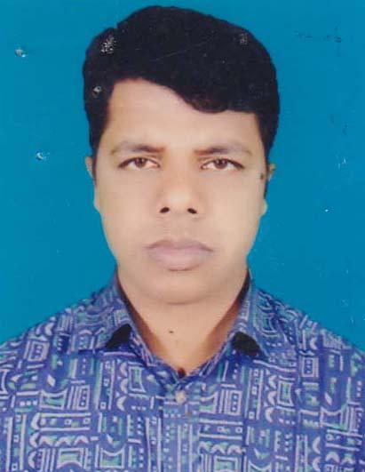 | DR. MD. AKSHAD AL MASUR (ANON)  F/Name: Md. Nazrul Islam  M/Name: Asma Islam  BM & DC Reg. No: 39666  NID: 2696352220274  Cell: 01712218118  Address: 4th Floor, PDC Hospital, Hospital Road, Salgaria, Pabna  Blood Group: O+
102 | Voter No  LM-5000102 | DR. SANJAY KUMAR SARKER  F/Name: Nimai Chandra Sarker  M/Name: Maya Rani Sarker  BM & DC Reg. No: 51180  NID: 7625507155361  Cell: 01717487807  Address: C/O: Dr. Modhusudan Bishwas, Shalgaria, Thanapara, Pabna  Blood Group: A+
103 | Voter No  LM-5000103 | DR. A. N. M. MOZAMMEL HAQUE  F/Name: Late. Mofiz Uddin Mandol  M/Name: Mrs. Amina Begum  BM & DC Reg. No: 25638  NID: 8192214109355  Cell: 01713793987  Address: Hospital Quarter, PMCH, Pabna  Blood Group: O+
104 | Voter No  LM-5000104  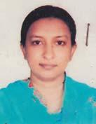 | DR. AMINA KHATUN  F/Name: Md. Noor-e-Rahman  M/Name: Mrs. Shamsun Nahar  BM & DC Reg. No: 27967  NID: 7625508159981  Cell: 01715595746  Address: Shalgaria, Gorosthan Road, Pabna Sadar, Pabna  Blood Group: B+
105 | Voter No  LM-5000105 | DR. TASNIM TAMANNA SWARNA  F/Name: Shekh Ibai  M/Name: Tahera Nargis  BM & DC Reg. No: 39329  NID: 7623904519203  Cell: 01731003396  Address: C/O: Shekh Ibai (Advocate), Moshuria Para, Akbore More, Post: Ishurdi, Dist: Pabna  Blood Group: B+
106 | Voter No  LM-5000106 | DR. S. M. AZIZUR RAHMAN  F/Name: Nazim Uddin  M/Name: Sufia Begum  BM & DC Reg. No: 48480  NID: 2697556419309  Cell: 01712588001  Address: Upazilla Health Complex, Bhangura, Pabna  Blood Group: A+
107 | Voter No  LM-5000107  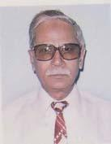 | DR. ILIAS IFTIKHAR RASUL  F/Name: Late. Md. Isa  M/Name: Late. Motaharun Nissa  BM & DC Reg. No: 3093  NID: 7625507154598  Cell: 01818938667  Address: G-56, Bansia, Shaha Rd, Salgaria, Pabna  Blood Group: B+
108 | Voter No  LM-5000108 | DR. NAZIA HASSAN  F/Name: Md. Abdus Salam Mia  M/Name: Salma Begum  BM & DC Reg. No: 44977  NID: 2693014492553  Cell: 01916840205  Address: C/O: Md. Abdus Salam Mia, Vill: Zellapara, Post: Pabna, Upazilla: Pabna Sadar, Dist: Pabna  Blood Group: A+
109 | Voter No  LM-5000109 | DR. SALEH MUHAMMAD ALI  F/Name: Muhammad Ali  M/Name: Saleha Ali  BM & DC Reg. No: 43443  NID: 2691648087205  Cell: 01718187154  Address: Assistant Surgeon, Laxmipur Union Sub-Centre, Atghoria, Pabana  Blood Group: B+
110 | Voter No  LM-5000110 | DR. MD. ABDUL BATEN  F/Name: Md. Abdur Rahman  M/Name: Late. Jomela Khatun  BM & DC Reg. No: 20988  NID: 7623907531506  Cell: 01711198105  Address: Sher Sha Road, Ishwardi, Pabna  Blood Group: O+
111 | Voter No  LM-5000111 | DR. HASAN-AL-HABIB  F/Name: A. K. M. Azad  M/Name: Mrs. Nazma Begum  BM & DC Reg. No: 48467  NID: 2697556419308  Cell: 01727701606  Address: Vill: Ramchandrapur, Goshpara, PO & Dist: Pabna  Blood Group: B+
112 | Voter No  LM-5000112  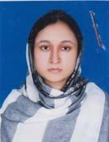 | DR. FARJANA MAHJABIN  F/Name: Md. Khorshed Hossain  M/Name: Afsana Nur  BM & DC Reg. No: 54154  NID:  Cell: 01717429749  Address: Al-Amin, Vill: South Raghabpur, Thana: Pabna Sadar, Dist: Pabna  Blood Group: B+
113 | Voter No  LM-5000113 | DR. SHEULY RANI SAHA  F/Name: Prodyot Kumar Saha  M/Name: Rina Rani Saha  BM & DC Reg. No: 42344  NID: 2696352224205  Cell: 01716180768  Address: Vill: Gopalpur, Post: Pabna, Dist: Pabna  Blood Group: O+
114 | Voter No  LM-5000114  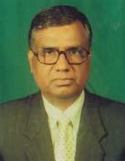 | CAPT (RETD) DR. MUHAMMAD ANISUR RAHMAN  F/Name: Late. Monsur Ali  M/Name: Late. Diljan Begum  BM & DC Reg. No: 7266  NID: 7625507152381  Cell: 01711859194  Address: PDC Hospital Road, Salgaria, Pabna  Blood Group: AB_po
115 | Voter No  LM-5000115 | DR. RAFFAT SULTANA  F/Name: Md. Rekat Ali  M/Name: Rashida Khatun  BM & DC Reg. No: 48246  NID: 8524904042887  Cell: 01716967365  Address: House: 2201, Block: H, P.N Bilane, Masum Bazar, East Shalgaria, Pabna  Blood Group: A+
116 | Voter No  LM-5000116  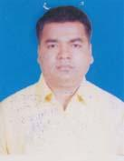 | DR. SHYAMAL KUMAR ROY  F/Name: Late. Nagendra Nath Roy  M/Name: Gurudasi Das  BM & DC Reg. No: 25394  NID:  Cell: 01720543642  Address: Doctors Qtr, UHC, Ishwardi, Pabna  Blood Group: A+
117 | Voter No  LM-5000117  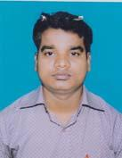 | DR. MD. SHAFIQUL ISLAM  F/Name: Md. Meher Ullah  M/Name: Mrs. Ronjuara Begum  BM & DC Reg. No: 40413  NID: 761298546304  Cell: 01711462128  Address: Alhaj Moor, Ishurdi, Pabna  Blood Group: AB_po
118 | Voter No  LM-5000118  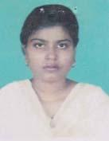 | DR. MST. ARMINA NAZNEEN  F/Name: Md. Azmal Hossain  M/Name: Dil Ruba  BM & DC Reg. No: 40797  NID: 7613963639397  Cell: 01716077357  Address: Vill: Gorgori, PO: Digha, PS: IShwardi, Dist: Pabna  Blood Group: O+
119 | Voter No  LM-5000119 | DR. MD. MOYEZ UDDIN AHMED PRODHAN  F/Name: Md. Abdul Huq Prodhan  M/Name: Monowara Begum  BM & DC Reg. No: 31503  NID: 2699040687925  Cell: 01191192045  Address: Sasthosheba Hospital, Goshpara, Pabna.  Blood Group: O+
120 | Voter No  LM-5000120 | DR. GUTOM KUMAR GHOSH  F/Name: Gour Chandra Ghosh  M/Name: Urmila Rani Ghosh  BM & DC Reg. No: 24982  NID: 8198503435612  Cell: 01712997605  Address: Assistant Professor (Surgery) (Current-Change), Pabna Medical College, Pabna  Blood Group: O+
121 | Voter No  LM-5000121 | DR. K. M. ASHRAFUZZAMAN  F/Name: Md. Seraj Uddin Khan  M/Name: Mst. Meherunnesa Khanoom  BM & DC Reg. No: 7983  NID: 19552691651000001  Cell: 01711193258  Address: Divisional Director (Health), Rajshahi Division, Rajshahi  Blood Group:
122 | Voter No  LM-5000122 | DR. KHONDKER SAJJAD HOSSAIN  F/Name: Khandaker Golam Mansur  M/Name: Late. Mrs. Shamsun Nahar  BM & DC Reg. No: 13465  NID: 7625515201863  Cell: 01712083656  Address: Upazilla Health Complex, Sujanagar, Pabna  Blood Group: O+
123 | Voter No  LM-5000123 | DR. NURUZZAMAN  F/Name:  M/Name:  BM & DC Reg. No: 41556  NID: 2691650147683  Cell: 01717443467  Address: Upazilla Health Complex, Atghoria, Pabna  Blood Group: B+  TRANSFERED to BMA Dhaka City  LM-1405543
124 | Voter No  LM-5000124 | DR. MUHAMMAD SIRAJUL ISLAM (SHUVO)  F/Name: Md. Abdul Hamid  M/Name: Nargis Hamid  BM & DC Reg. No: 34273  NID: 2610413911352  Cell: 01711316254  Address: Gobindha Dewan Bari Mosque, Gobidha, Pabna  Blood Group: O+
125 | Voter No  LM-5000125 | DR. MOUMITA TALUKDER  F/Name: Late. Bikash Chandra Talukder  M/Name: Shipa Talukder  BM & DC Reg. No: 45075  NID: 2699238608550  Cell: 01717839203  Address: C/O: Dr. Ripon Kumar Das, Vill: Santhia Bazar, Upazilla: Santhia, Dist: Pabna  Blood Group: A+
126 | Voter No  LM-5000126 | JANNATUL FERDOUS  F/Name: Rashidunnabi Farid  M/Name: Fazilatunnessa  BM & DC Reg. No: 46353  NID: 2697556370647  Cell: 01818674002  Address: Assistant Surgeon, Goyeshpur Union Sub-Centre, Sadar, Pabna  Blood Group: O+
127 | Voter No  LM-5000127 | DR. MD. ALI REZA FARUQUE  F/Name: Late. Abdul Quddus  M/Name: Mst. Fazila Khatun  BM & DC Reg. No: 42661  NID: 2694811655037  Cell: 01717217237  Address: Upazilla Health Complex, Bera, Pabna  Blood Group: A+
128 | Voter No  LM-5000128 | DR. MD. AHASANUL HAQUE  F/Name: Md. Abdur Razzaq  M/Name: Elizia Islam  BM & DC Reg. No: 46774  NID: 6125214284268  Cell: 01712003598  Address: Doctors Quarter, UHC Atgharia, Pabna  Blood Group: B+
129 | Voter No  LM-5000129 | DR. NASIMA AFROZ  F/Name: Md. Abdus Sattar  M/Name: Begum Shamsun Nahar  BM & DC Reg. No: 46827  NID: 7625513194248  Cell: 01816256960  Address: Smrity Kunjo, Holding: 66, Atua, Kalabagan, Pabna  Blood Group: A+
130 | Voter No  LM-5000130 | DR. MD SANWAR NAWAZ KHAN  F/Name: Md Abdus Sattar Khan  M/Name: Mrs Shohela Sultana  BM & DC Reg. No: A-50973  NID:  Cell:  Address: H/N 282/03, Nazimuddin Road Vill- Gobinda, Po- Pabna, Pabna Sadar, Pabna  Blood Group:
131 | Voter No  LM-5000131 | DR. MOHAMMAD FAISAL ZINNAT  F/Name: Mohammad Zinnat Ali  M/Name: Fatema Zinnat  BM & DC Reg. No: 49888  NID: 2693016228846  Cell: 01717306033  Address: Dept. of Anaesthesiology, 250 Bedded General Hospital, Pabna  Blood Group: AB_po
132 | Voter No  LM-5000132 | DR. MD. MUNZUR ALAHI  F/Name: Late. Akkas Ali  M/Name: Mrs. Rahima Bewa  BM & DC Reg. No: 39446  NID: 7625503130074  Cell: 01712177129  Address: Pabna Swasthoseba Hospital, Gochpara, Pabna  Blood Group: O+
133 | Voter No  LM-5000133 | DR. MD. SHERAJUL ISLAM  F/Name: Md. Sohrab Ali  M/Name: Shahanara Begum  BM & DC Reg. No: 36158  NID: 7615543413465  Cell: 01818652987  Address: Medical Officer, UHC, Atghoria, Pabna  Blood Group: B+
134 | Voter No  LM-5000134 | DR. MD. ZAHID HOSSAIN  F/Name: Md. Anisur Rahman  M/Name: Mrs. Maleka Rahman  BM & DC Reg. No: 48817  NID: 7625503129803  Cell: 01710493925  Address: Pabna Medical College, Pabna  Blood Group: A+
135 | Voter No  LM-5000135 | DR. MAHMUDA NAZNIN  F/Name: Md. Mahbubur Rahman  M/Name: Mrs. Kohinoor Begum  BM & DC Reg. No: 53034  NID: 8198506402687  Cell: 01717015431  Address: Chest Disease Hospital, Pabna  Blood Group: A+
136 | Voter No  LM-5000136 | DR. PORIMAL KUMAR DAS  F/Name: Late. Sukumar Chandra Das  M/Name: Saraswati Rani Das  BM & DC Reg. No: 38166  NID: 2696655316326  Cell: 01711339152  Address: Holding: 195, Mozamdarpara Road, Radhanagar, Pabna.  Blood Group: O+
137 | Voter No  LM-5000137 | DR. MD. ABDUL AWAL  F/Name: Md. Ansar Ali  M/Name: Most. Ayesha Khatun  BM & DC Reg. No: 41895  NID: 7618395355142  Cell: 01678112560  Address: Asst. Surgeon, Sujanagar Health Complex, Pabna  Blood Group: O+
138 | Voter No  LM-5000138 | DR. MD. SHAMSUL HAQUE  F/Name: Md. Abdul Halim  M/Name: Mrs. Saleha Khatun  BM & DC Reg. No: 44881  NID: 7613952564692  Cell: 01712128323  Address: Upazilla Health Complex, Faridpur, Pabna  Blood Group: O+
139 | Voter No  LM-5000139 | DR. SADIA SHAHRIN  F/Name: Md. Momtaz Uddin  M/Name: Khurshid Ara Begum  BM & DC Reg. No: 48819  NID: 3323021487054  Cell: 01711427552  Address: Dept. of Gynaecology & Obs, 250 Bedded General Hospital, Pabna  Blood Group: B+
140 | Voter No  LM-5000140  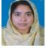 | DR. MST JANNATUN NAHER  F/Name: Md Gias Uddin  M/Name: Mst Moriom Begum  BM & DC Reg. No: A-43188  NID:  Cell:  Address: Uhc Chatmohor  Pabna  Blood Group:
141 | Voter No  LM-5000141  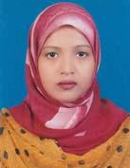 | DR. MST. AFROZA KHATUN  F/Name: Late. Azizul Haque  M/Name: Most. Monowara Begum  BM & DC Reg. No: 48207  NID: 19828524904042229  Cell: 01749021547  Address: Vill: Kalinagar, PO: Chatmohor Notun Bazar, PS: Chatmohor, Dist: Pabna  Blood Group: B+
142 | Voter No  LM-5000142 | DR. JENEFER YESMIN  F/Name: Md. Matiar Rahman  M/Name: Mrs. Monowara Rahman  BM & DC Reg. No: 52223  NID: 6125214204894  Cell: 01914857935  Address: C/O: Md. Matiar Rahman, Vill: Gopalpur, Post: Pabna, Upazilla: Pabna Sadar, Dist: Pabna  Blood Group: O+
143 | Voter No  LM-5000143  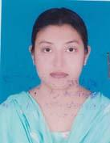 | DR. JANNATUL FERDOSE  F/Name: Mirza Md. Azizur Rahman  M/Name: Anowara Rahman  BM & DC Reg. No: 51917  NID: 8524904189548  Cell: 01746155252  Address: Daisy Lodge, Narayanpur, Radhanagar, Pabna  Blood Group: B+
144 | Voter No  LM-5000144  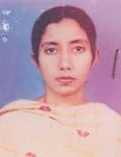 | DR. BILKIS SULTANA  F/Name: Md. Babar Karim  M/Name: Sultana Mahmuda Akter  BM & DC Reg. No: 41478  NID: 7625511175480  Cell:  Address: M O, School Health Centre, Pabna  Blood Group: B+
145 | Voter No  LM-5000145 | DR. MD. KAMRUZZAMAN  F/Name: Late. Joyen Uddin Pramanik  M/Name: Mrs. Ambia Khatun  BM & DC Reg. No: 50652  NID: 8198510366866  Cell: 01815267601  Address: Emergency Medical Officer, Upazilla Health Complex, Faridpur, Pabna  Blood Group: A+
146 | Voter No  LM-5000146 | DR. FATEMA FAIRUJ SAMAD  F/Name: SK. Md. Abdus Samad  M/Name: Mahfuza Khanam  BM & DC Reg. No: 45098  NID: 2696352212866  Cell: 01816421642  Address: South Ramchandrapur, Pabna  Blood Group: B+
147 | Voter No  LM-5000147 | DR. NAOROZE FERDOUS  F/Name: Md. Shahidullah  M/Name: Tahmina Sultana  BM & DC Reg. No: 45824  NID: 2697408866523  Cell: 01718858259  Address: Pabna Medical College  Blood Group: O+
148 | Voter No  LM-5000148 | DR. MD. GOLAM SHAROAR  F/Name: Md. Nazim Uddin  M/Name: Mrs. Anwara Begum  BM & DC Reg. No: 44192  NID: 19807611915000005  Cell: 01717249211  Address: Doctors Quarter, General Hospital, Pabna  Blood Group: AB_po
149 | Voter No  LM-5000149  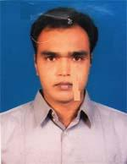 | DR. RATAN KUMAR ROY  F/Name: Khagendra Nath Roy.  M/Name: Kanchan Prava Roy .  BM & DC Reg. No: 27809  NID: 8819494747613  Cell: 01712274911  Address: Medical College Hospital.  Blood Group: B+
150 | Voter No  LM-5000150 | DR. S.M GOLAM MOULA  F/Name: Md. Abdul Mottalib Sarkar  M/Name: Mrs. Firoza Begum  BM & DC Reg. No: 53391  NID: 8524904043185  Cell: 8524904043185  Address: Upazilla health complex, chatmohor, pabna  Blood Group: O+
151 | Voter No  LM-5000151  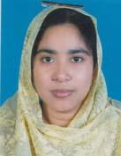 | DR. MST. JANNATUN NAHER (LATA)  F/Name: Md. Gias Uddin  M/Name: Mst. Moriom Begum  BM & DC Reg. No: 43188  NID: 7622203953506  Cell: 01712275069  Address: Baluchor, Chatmohar, Pabna  Blood Group: B+
152 | Voter No  LM-5000152  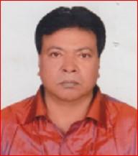 | DR. AHMED ARIF  F/Name: Late Hazi Azim Uddin Ahmed  M/Name: Rokeya Begum  BM & DC Reg. No: 15131  NID: 7625502116842  Cell: 01711117178  Address: House: Nirjhor, Lahiripara, Gopalpur, Pabna.  Blood Group: O+
153 | Voter No  LM-5000153  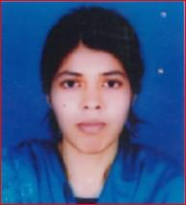 | DR. ALFE SHAHRIN  F/Name: Dr. Ahmed Arif  M/Name: Dr. Shahin Ferdous  BM & DC Reg. No: 68201  NID: 19907625502000114  Cell: 01726101090  Address: Nirjhar, Lahiripara, Gopalpur, Pabna.  Blood Group: O+
154 | Voter No  LM-5000154  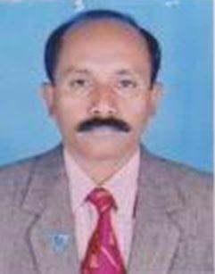 | DR. TANMAY PRAKASH BISWAS  F/Name: Sree Birat Chandra Biswas  M/Name:  BM & DC Reg. No: 16144  NID:  Cell: 01711-261897  Address: Professor of Psychiatry & Director  Pabna Mental Hospital,  Pabna  Blood Group:
155 | Voter No  LM-5000155 | DR. RAYA ADIBA HAQUE  F/Name: Md. Reazul Haque  M/Name: Suraya Haque  BM & DC Reg. No: 23993  NID: 19897615543387594  Cell: 01754811976  Address: Balarampur, Char Ashutashpur Pabna Sadar, Pabna-6600.  Blood Group: O+
156 | Voter No  LM-5000156  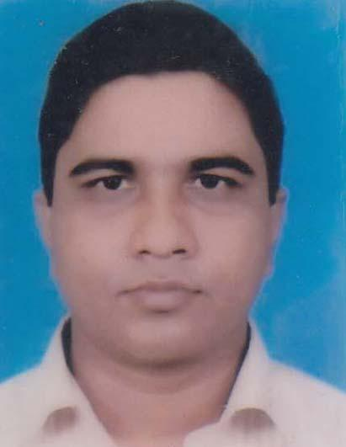 | DR. SHEIKH MOHAMMAD RAFIQUL HOSSAIN  F/Name: Mohammad Sekender Ali Sheikh  M/Name: Mrs. Saleha Begum  BM & DC Reg. No: 23993  NID: 6125214204934  Cell: 01711478813  Address: Assit Prof Pabna Medical College, Pabna.  Blood Group: O+
157 | Voter No  LM-5000157  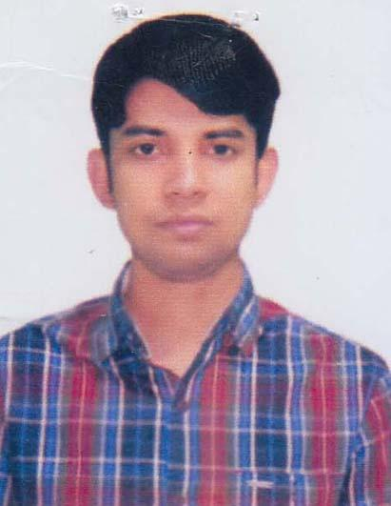 | DR. SAIKAT BIN ASAD  F/Name: A.b.m. Asadul Islam  M/Name: Ferousi Asad  BM & DC Reg. No: 78492  NID: 19927618357000110  Cell: 01724776444  Address: Vill: Morispuran, P.O: Kashinathpur, U.Zila: Shantaia, Dist: Pabna.  Blood Group: A+
158 | Voter No  LM-5000158 | DR. MRS. MAHMUDA KHATUN  F/Name: Md. Ayub Ali  M/Name: Mrs. Moriom Khatun  BM & DC Reg. No: 75194  NID: 7611663049128  Cell: 01732824065  Address: Kashinathpur, Shanthia, Pabna.  Blood Group: A+
159 | Voter No  LM-5000159 | DR. S.M SAIFUL AZAM SONY  F/Name: Hazrat Ali  M/Name: Saifon Nessa  BM & DC Reg. No: 62900  NID: 19882693717194221  Cell: 01717054498  Address: Balarampur, Char Ashutoshpur Pabna Sadar, Pabna.  Blood Group: O+
160 | Voter No  LM-5000160  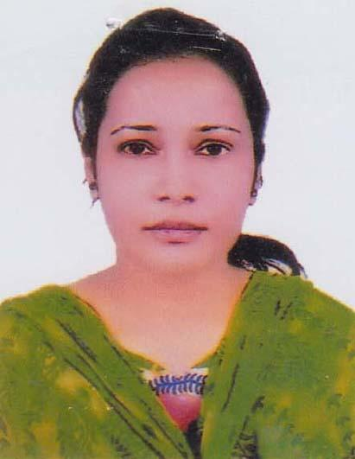 | DR. MAHMUDA SULTANA  F/Name: Mostafizur Rahman  M/Name: Ferdaushi Rahman  BM & DC Reg. No: 78490  NID: 19911022009600006  Cell: 01704222811  Address: Vill: Morispuran, P.O: Kashinathpur, U.Zilla: Santhia, Dist: Pabna.  Blood Group: A+
161 | Voter No  LM-5000161 | DR. MD. ABU TALEB  F/Name: Md. Shomsher Ali  M/Name: Aklima Khanam  BM & DC Reg. No: 4277  NID: 0695111185437  Cell: 01724109597  Address: General Hospital Pabna.  Blood Group: A+
162 | Voter No  LM-5000162  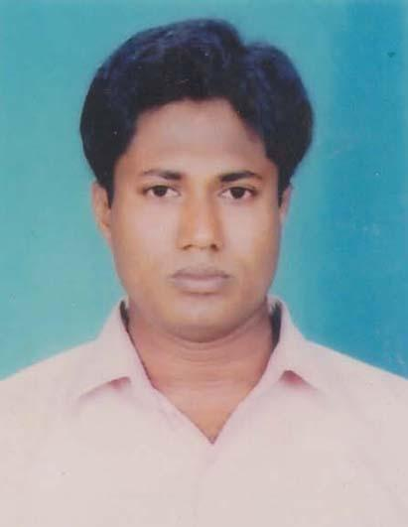 | DR. MD. RASHEEDUL HAQUE  F/Name: Late Aynul Haque  M/Name: Mrs. Salina Khanom  BM & DC Reg. No: 39921  NID: 8198514109448  Cell: 01740599309  Address: 250 Bedded General Hospital Pabna.  Blood Group: O+
163 | Voter No  LM-5000163  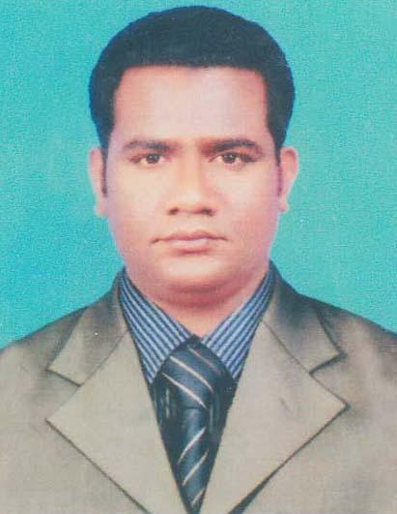 | DR. MD. ENAMUL HAQUE  F/Name: Abdul Latif  M/Name: Sabura Khatun  BM & DC Reg. No: 60345  NID: 19882924709173766  Cell: 01722244020  Address: General Hospital Pabna.  Blood Group: A+
164 | Voter No  LM-5000164  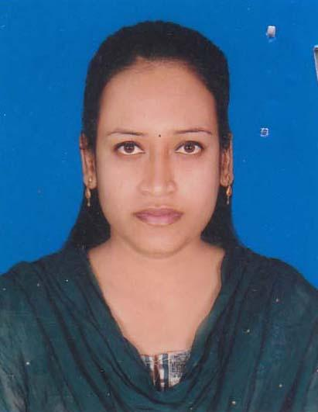 | DR. SAYADA JOHURA LIZA  F/Name: Md. Sayedullah Miah  M/Name: Jesmin  BM & DC Reg. No: 58912  NID: 5981725392  Cell: 01717338190  Address: 1/A, Kalachadpara, Taltola Pukur, Pabna Sadar, Pabna-6600.  Blood Group: A+
165 | Voter No  LM-5000165  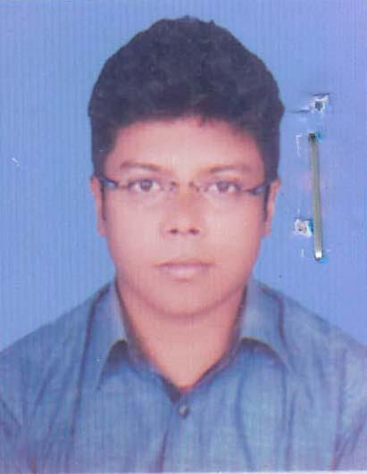 | DR. RAFIUL ISLAM SHUVO  F/Name: Shahidul Islam  M/Name: Shahina Sultana  BM & DC Reg. No: 87729  NID: 1910038551  Cell: 01780707781  Address: Jorbangla Para, Pabna.  Blood Group: B+
166 | Voter No  LM-5000166  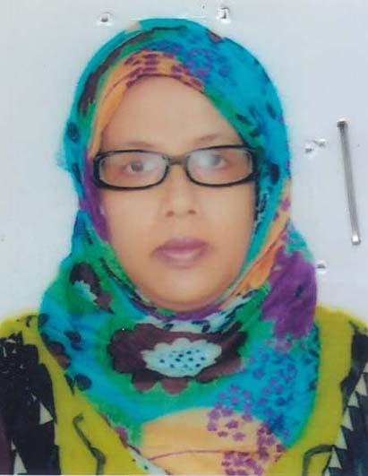 | DR. FARHANA HAMID TINA  F/Name: Late Khandakar Abdul Hamid  M/Name: Mahmuda Khandakar  BM & DC Reg. No: 43661  NID: 7771604522  Cell: 01816526549  Address: Pailanpur, Power House Para, Pabna Sadar, Pabna.  Blood Group: A+
167 | Voter No  LM-5000167  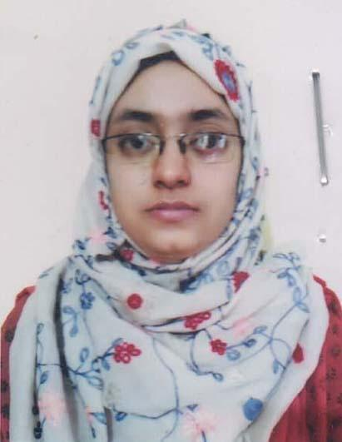 | DR. MUNMUN MAHMUD  F/Name: Mahmudur Rahman  M/Name: Momtaj Mahmud  BM & DC Reg. No: 58084  NID: 7625510173781  Cell: 01716931692  Address: Medical Officer, 250 Bedded General Hospital, Pabna  Blood Group: O+
168 | Voter No  LM-5000168 | DR. MD. ZAHIDUL ISLAM  F/Name: Md. Abdul Jalil Khan  M/Name: Mst. Nurnahar Begum  BM & DC Reg. No: 54063  NID: 19849196208184904  Cell: 01751821572  Address: Medical Officer, 250 Bedded General Hospital, Pabna.  Blood Group: O-
169 | Voter No  LM-5000169  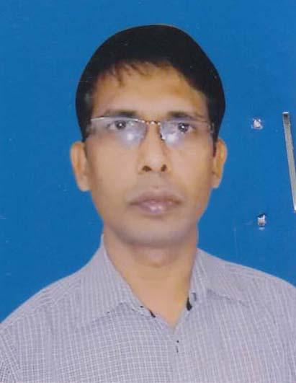 | DR. BIPLOB KUMAR SAHA  F/Name: Late Chitish Chandro Saha  M/Name: Renuka Bala Saha  BM & DC Reg. No: 29140  NID:  Cell: 01726691620  Address: Gopalpur, Pabna.  Blood Group: B+
170 | Voter No  LM-5000170  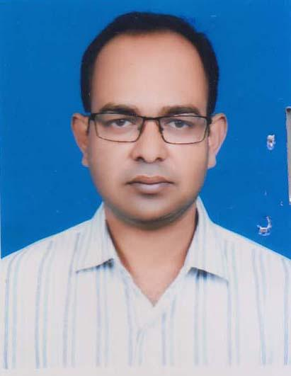 | DR. KH. MEHEDY IBNAY MOSTOFA  F/Name: Kh. Golam Mostofa  M/Name: Anwara Begum  BM & DC Reg. No: 39611  NID:  Cell: 01914414942  Address: Lecturer Communiy Medicine, Pabna Medical College.  Blood Group: O+
171 | Voter No  LM-5000171  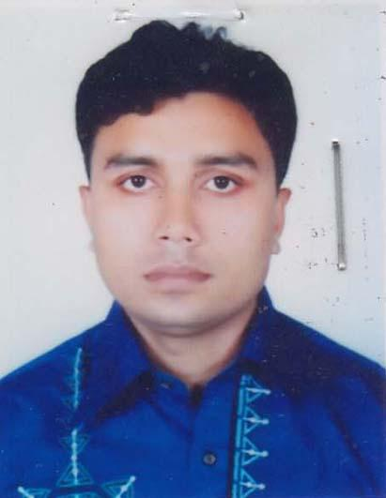 | DR. MD. MIR SUFIAN  F/Name: Md. Mir Shad Uddollah  M/Name: Sufia Khatun  BM & DC Reg. No: 44133  NID: 4196125639  Cell: 01717622901  Address: 250 Bedded Gen. Hospital, Pabna.  Blood Group: AB+
172 | Voter No  LM-5000172 | DR. MD. QUAM RUZZAMAN  F/Name: Late Abdul Karim  M/Name: Montaha Karim  BM & DC Reg. No: 51217  NID: 6449609525  Cell: 01712697105  Address: Vill: Rajapur, P.O: Callio cotton Mills Ltd, P.S: Pabna Sadar, Pabna.  Blood Group: O+
173 | Voter No  LM-5000173  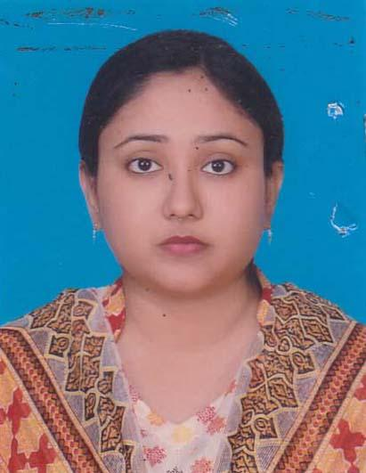 | DR. SUMAIYA RAHMAN  F/Name: Md. Anisur Rahman  M/Name: Mahbuba Shireen  BM & DC Reg. No: 60729  NID: 7316786842  Cell: 01715134003  Address: PDC Hospital, Shalogaria, Pabna.  Blood Group: O+
174 | Voter No  LM-5000174  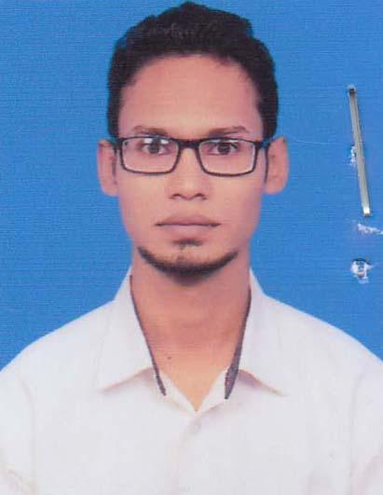 | DR. MD. JAHID HASSAN JIM  F/Name: Md. Abu Baker  M/Name: Most Farida Yasmin  BM & DC Reg. No: 92117  NID: 3705862690  Cell: 01787284877  Address: Dilalpur, Pabna.  Blood Group: B+
175 | Voter No  LM-5000175  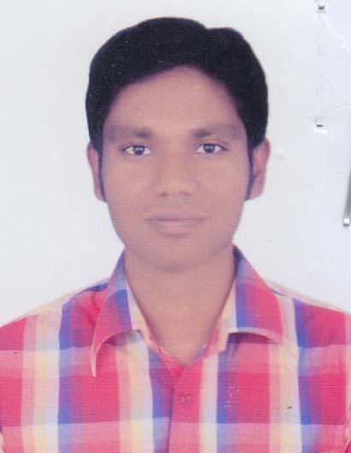 | DR. MIR TOUHEDUL ISLAM  F/Name: Mir Afzalur Rahman  M/Name: Asma Afzal  BM & DC Reg. No: 56504  NID: 19866125210179286  Cell: 01717-622901  Address: 1/A Kalachadpara, Taltola Pukur Par, Pabna Sadar, Pabna-6600.  Blood Group: A+
176 | Voter No  LM-5000176  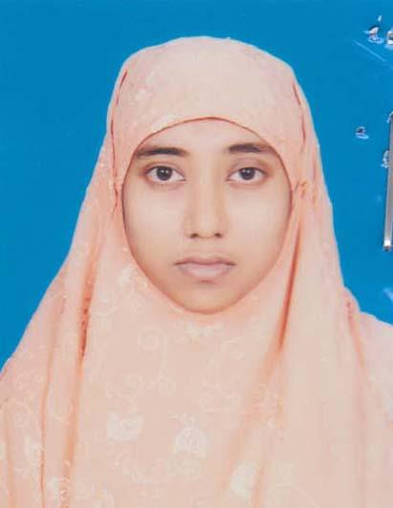 | DR. RAFIYA AFROZ  F/Name: Md. Abdur Rahman  M/Name: Shefali Khatun  BM & DC Reg. No: 66691  NID: 19902697556000269  Cell: 01729564645  Address: Vill: Ramchandrapur, Ghoshpara, Thana: Pabna Sadar, Dist: Pabna.  Blood Group: A+
177 | Voter No  LM-5000177  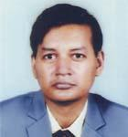 | DR. MD. SHARIFUL ISLAM  F/Name: Late Nazrul Islam  M/Name: Selina Islam  BM & DC Reg. No: A-48080  NID: 3716635051  Cell: 01556330864  Address: Shalgaria, Pabna Sadar, Pabna.  Blood Group: B+
178 | Voter No  LM-5000178 | DR. MD. SHAMSUL ALAM  F/Name: Sekendar Ali  M/Name: Romela Khatun  BM & DC Reg. No: 42136  NID: 4820606426663  Cell: 01712546540  Address: Road-5, Monsurabad, Pabna.  Blood Group: A+
179 | Voter No  LM-5000179  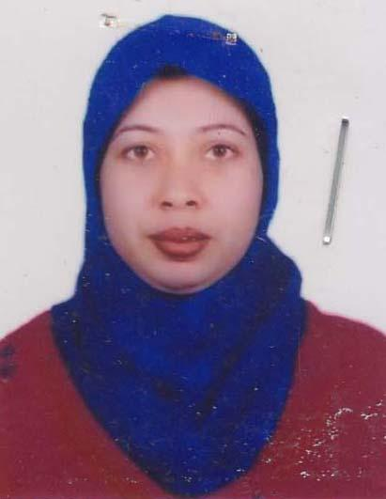 | DR. SHAHANAJ AKTER  F/Name: Md. Azgor Ali  M/Name: Asma Yesmin  BM & DC Reg. No: 43107  NID: 5993164952  Cell: 01716472217  Address: Road-05, Monsurabad, Pabna.  Blood Group: A+
180 | Voter No  LM-5000180  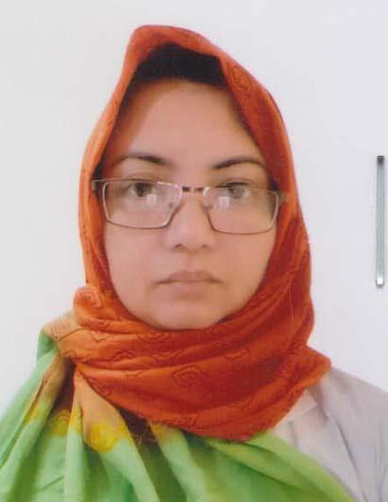 | DR. KHANDKER MAHBUBA JANNAT  F/Name: Khandker Abdul Matin  M/Name: Gulshan Ara Matin  BM & DC Reg. No: 42851  NID: 5519692767  Cell: 01711935464  Address: Sayed Bari, KG Shaha Road, Shalgaria, Pabna.  Blood Group: B+
181 | Voter No  LM-5000181 | DR. MD. JAHIR UDDIN KHAN  F/Name: Md. Abdul Khan  M/Name: Most. Jobeda Khatun  BM & DC Reg. No: 74370  NID: 2370839355  Cell: 01738238684  Address: Flat No: 403, R-S Plaza, Boro Bazar, Pabna Sadar, Pabna.  Blood Group: B+
182 | Voter No  LM-5000182 | DR. MD. ABDUS SALAM  F/Name: Late: Abdul Jabber  M/Name: Mrs. Hanufa Begum  BM & DC Reg. No: A  NID: 2367111396  Cell:  Address: Ultra Modern Diagnostic Center, Kashinathpur Bazaar, Kashinathpur, Santhia, Pabna  Blood Group: O+
183 | Voter No  LM-5000183  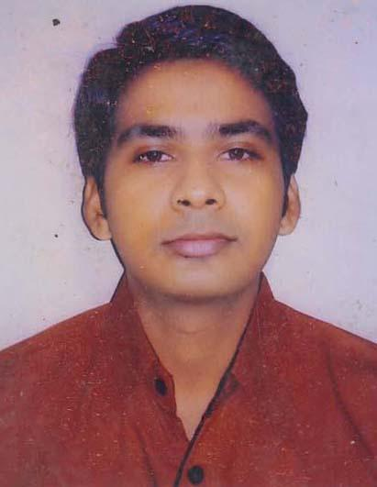 | DR. ABDULLAH AL RASHID  F/Name: Habibur Rahman  M/Name: Rokeya Khatun  BM & DC Reg. No: 74447  NID:  Cell: 01731444208  Address: Jaman Health Care & Diag. Center, Kahinathpur, Pabna.  Blood Group: B+
184 | Voter No  LM-5000184 | DR. NAZMUL HAQUE  F/Name: Md. Nurul Haque  M/Name: Mst. Sharifun Nessa  BM & DC Reg. No: 19379  NID:  Cell: 01712144999  Address: Upazilla Health Coplex Bera, Pabna.  Blood Group: A+
185 | Voter No  LM-5000185  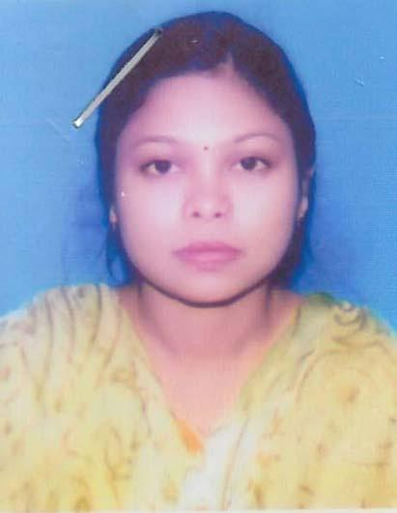 | DR. FATEMA TUJ JANNAT  F/Name: Md. Jahangir Alom  M/Name: Nur Mahal Begum  BM & DC Reg. No: 52137  NID: 8827810164830  Cell: 01816648044  Address: UHC, Bera, Pabna.  Blood Group: AB+
186 | Voter No  LM-5000186 | DR. MD. ABDULLAH RUMI  F/Name: Md. Abdul Wahab  M/Name: Late: Babli Aklima Khatun  BM & DC Reg. No: A 9245  NID: 2817097989  Cell:  Address: Shadhupara, Pabna.  Blood Group: AB+
187 | Voter No  LM-5000187  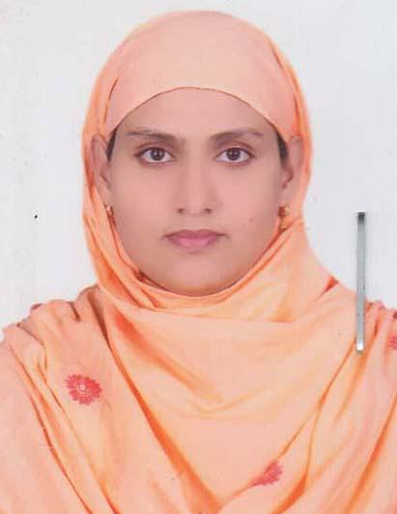 | DR. LUTFUN NAHAR  F/Name: Abdul Baset  M/Name: Kohinur Begum  BM & DC Reg. No: 66857  NID:  Cell: 01735790265  Address: Mondol Plaza, Sajanagar, Pabna.  Blood Group: O+
188 | Voter No  LM-5000188  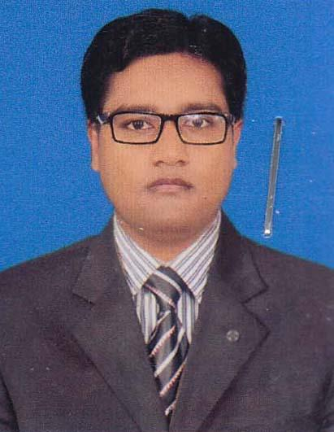 | DR. MD. MOSTAFIZUR RAHMAN  F/Name: Md. Mozahar Ali  M/Name: Nurunnahar Begum  BM & DC Reg. No: 70687  NID: 7615517439918  Cell: 01728726802  Address: Mondol Plaza, Near Hospital Sujanagar, Pabna.  Blood Group: O+
189 | Voter No  LM-5000189  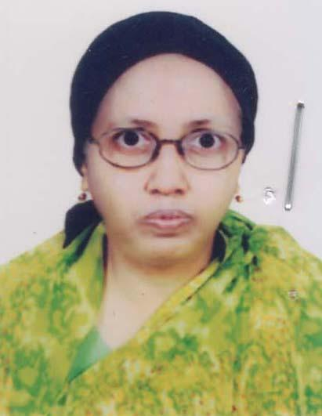 | DR. SABERA GULRUKH  F/Name: Md. Abdul Ghafur  M/Name: Rabeya Khatun  BM & DC Reg. No: 14810  NID: 7625502123050  Cell: 01819823992  Address: Sadhupara, Pabna.  Blood Group: O+
190 | Voter No  LM-5000190  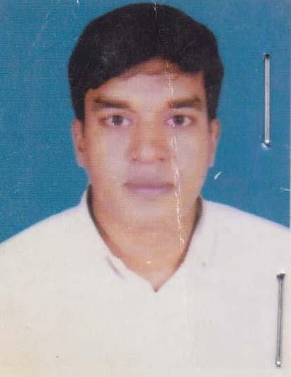 | DR. MD. MAJEDUL ISLAM  F/Name: Late Murad Ali  M/Name: Most. Rajia Khatun  BM & DC Reg. No: 41264  NID: 7613952573650  Cell: 01770382871  Address: 250 Bed Beneral Hospital, Pabna.  Blood Group: B+
191 | Voter No  LM-5000191  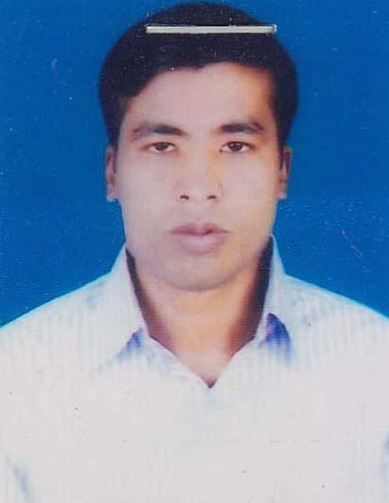 | DR. MD. SAJIB HOSSAIN  F/Name: Late Nayeb Ali  M/Name: Runa Begum  BM & DC Reg. No: 54626  NID: 8694728430  Cell: 01723254545  Address: Chalk Poilanpur, Pabna Sadar, Pabna.  Blood Group: O+
192 | Voter No  LM-5000192 | DR. RAFIQUL ISLAM  F/Name: Md. Abu Taher  M/Name: Nilufa Khatun  BM & DC Reg. No: 58932  NID: 3702471354  Cell:  Address: Senior Medical Officer, Pabna University Of Science & Technology.  Blood Group: A+
193 | Voter No  LM-5000193  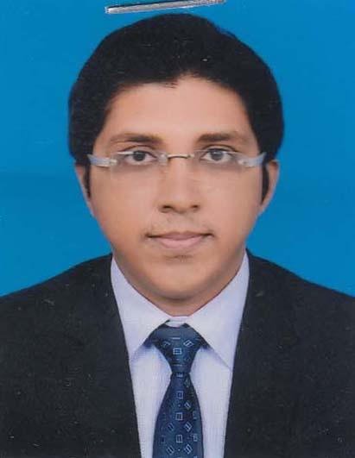 | DR. MD. BELAL HOSSAIN  F/Name: Md. Fazlul Haque  M/Name: Most Bilkis Banu  BM & DC Reg. No: 67426  NID: 4643488952  Cell: 01778572552  Address: Medical Officer, Medical Center, Pabna Science & Technology University.  Blood Group: B+
194 | Voter No  LM-5000194  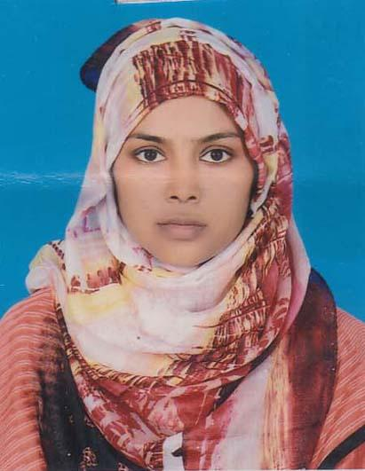 | DR. NASRIN SULTANA  F/Name: Md. Abdul Quddus  M/Name: Shahida Quddus  BM & DC Reg. No: 73949  NID: 6888679476  Cell: 01751094349  Address: Medical Officer, Medical Center, Pabna University Of Science & Technology, Pabna.  Blood Group: O+
195 | Voter No  LM-5000195 | DR. PROBIR KUMAR DATTA  F/Name: Late Morindra Nath Datta  M/Name: Late Beli Rani Datta  BM & DC Reg. No: 12665  NID: 8666648400  Cell: 01712985656  Address: Joykalibari Para, Thana Road, Shalgaria, Pabna.  Blood Group: A+
196 | Voter No  LM-5000196  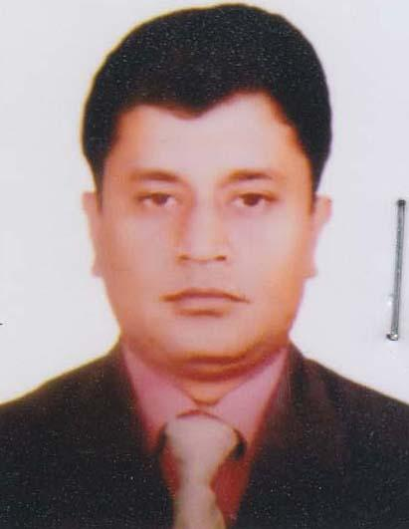 | DR. MD MASUD UN NABI  F/Name: Md. Mahfuz Un Nabi  M/Name: Rowshan Ara Begum  BM & DC Reg. No: 42850  NID: 5520095851  Cell: 01767472250  Address: Asst. Register(Medicine), 250 Bed General Hospital, Pabna.  Blood Group: A+
197 | Voter No  LM-5000197  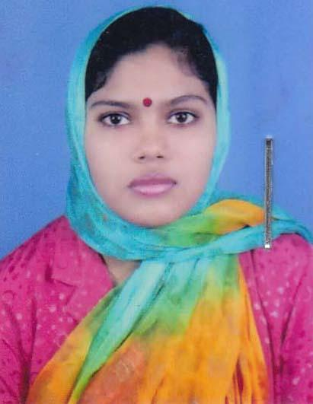 | DR. MST. MASUMA ANJUM DANA  F/Name: Md. Abdul Haque  M/Name: Mrs. Nasima Aktar  BM & DC Reg. No: 75623  NID: 8524904044145  Cell: 01729777456  Address: Aronkhola Road, Mosuriapara, Bokulermor, Ishwardi, Pabna.  Blood Group: O+
198 | Voter No  LM-5000198  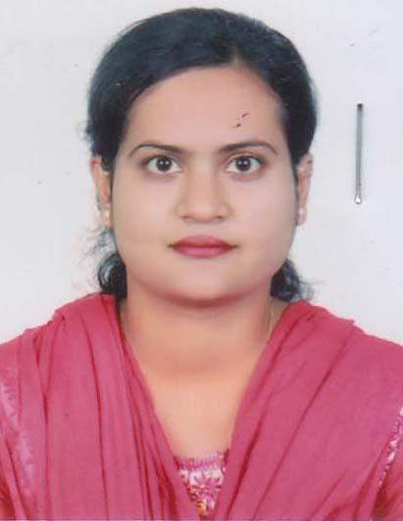 | DR. SABRINA RAHMAN  F/Name: Md. Azizur Rahman  M/Name: Rokeya Begum  BM & DC Reg. No: 81386  NID: 19927613952000028  Cell: 01739790992  Address: Aronkhola Road, Moshuria para, Bokulermor, Ishwardi, Pabna.  Blood Group:
199 | Voter No  LM-5000199  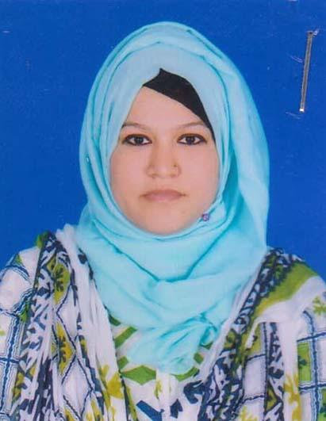 | DR. NESPATUL JANNAT  F/Name: Late Nurul Islam  M/Name: Jahanara Khatun  BM & DC Reg. No: 68985  NID: 19907623909000091  Cell: 01731892425  Address: Vill: Vallupara, Post&Thana: Ishward, Dist: Pabna.  Blood Group: B+
200 | Voter No  LM-5000200  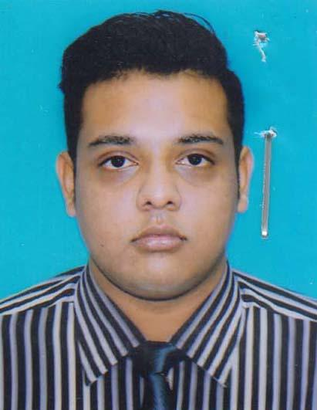 | DR. S.M. SHAMIUR RAHMAN  F/Name: Md. Mansur Rahman  M/Name: Shahanara Begum  BM & DC Reg. No: 83441  NID: 19907623903000054  Cell: 01717251252  Address: Rahman Matizil, Courtpara, Ishwardi, Pabna.  Blood Group: A+
201 | Voter No  LM-5000201  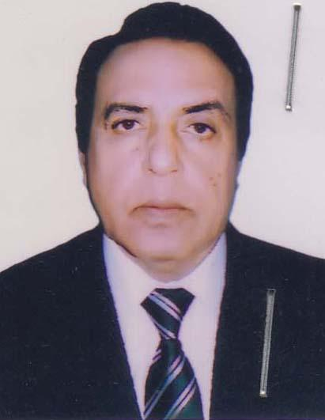 | DR. RAJENDRA NATH MEHTA  F/Name: Late Shankar Nath Mehta  M/Name: Mrs. Bowni Debi  BM & DC Reg. No: 7938  NID: 7623907534202  Cell: 01711976883  Address: Gorostam Road, Purba Tengri Shershah Road, Ishwardi, Pabna.  Blood Group: B+
202 | Voter No  LM-5000202 | DR. MD. MOFAZZAL HOSSAIN  F/Name: Md. Abdus Sattar  M/Name: Momotaz Begum  BM & DC Reg. No: 34618  NID: 762705380810  Cell: 01911068173  Address: Medical Officer Upazilla Health Complex Atghoria, Pabna.  Blood Group: O+
203 | Voter No  LM-5000203 | DR. MD. ANISUR RAHMAN  F/Name: Kamal Uddin Ahmed  M/Name: Amena Khatun  BM & DC Reg. No: 12896  NID: 19597621608014157  Cell: 01711469363  Address: Vill: Alhera Nagor, P.O: Bera, Upazilla: Bera, Dist: Pabna.  Blood Group: B+
204 | Voter No  LM-5000204 | DR. AZFAR BIN ANIS  F/Name: Dr. Md. Anisur Rahman  M/Name: Nasrin Begum  BM & DC Reg. No: 76304  NID: 19917621608000007  Cell: 01828170769  Address: Vill: Alhera Nagor, P.O: Bera, Upazila: Bera, Dist: Pabna.  Blood Group: O+
205 | Voter No  LM-5000205 | DR. MD. ANOWARUL ISLAM  F/Name: Mozammel Haque  M/Name: Fatema Begum  BM & DC Reg. No: A 33887  NID: 1917125609  Cell:  Address: Aatua Sauth para, Pabna.  Blood Group: B+
206 | Voter No  LM-5000206 | DR. MD. MOKHLESUR RAHMAN  F/Name: Late Abdul Hamid  M/Name: Mrs. Fazilatun Nesa  BM & DC Reg. No: 20457  NID: 1473137931  Cell: 01711224225  Address: Digital Diagnostic Centre, Sadar Thana Gate, Pabna.  Blood Group: B+
207 | Voter No  LM-5000207  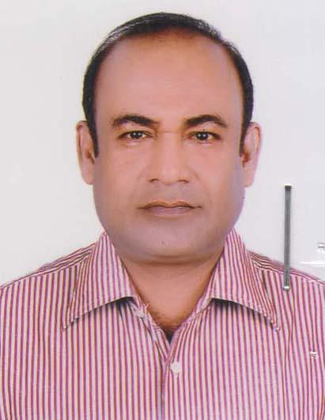 | DR. MD. NAZMUS SAQUIB  F/Name: Md. Mahboob -e- Elahi  M/Name: Moziron Nessa  BM & DC Reg. No: 19897  NID: 7625507152941  Cell: 01715002330  Address: Halima Clinic, Shalgaria, Ataikula Road, Pabna.  Blood Group: O+
208 | Voter No  LM-5000208  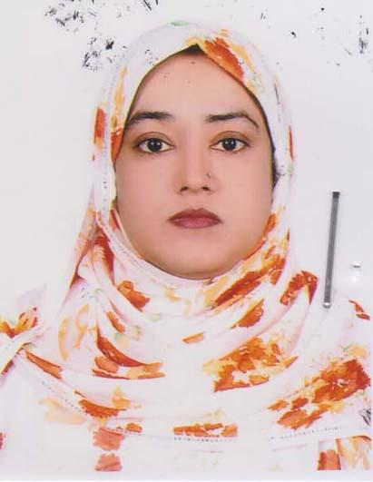 | DR. HALIMA KHATUN  F/Name: Md. Abdur Rahman Mollah  M/Name: Habiba Khatun  BM & DC Reg. No: 26529  NID: 7625507153200  Cell: 01720202431  Address: Halima Clinic, Shalgaria, Ataikula Road, Pabna.  Blood Group: B+
209 | Voter No  LM-5000209 | DR. KHONDAKER MOHAMMAD MUSTAFA ZAGLUL  F/Name: Kh.md. Rowshan Ali  M/Name: Mst. Rowshanara  BM & DC Reg. No: 7267  NID: 7611642096462  Cell: 01718242426  Address: Noybari, Kashinathpur, Aminpur, Bera, Pabna.  Blood Group: O+
210 | Voter No  LM-5000210  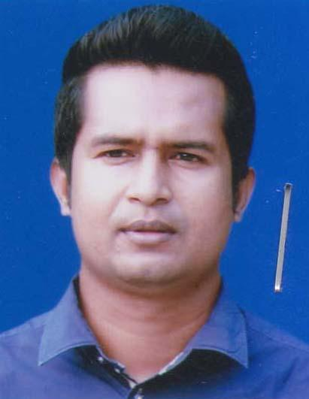 | DR. AHMED MOSTAFA NOMAN  F/Name: Late Jalal Uddin Mollah  M/Name: Mrs. Hamida Khatun  BM & DC Reg. No: 55866  NID: 7625505142105  Cell: 01711669770  Address: Shibrampur, Pabna Sadar, Pabna.  Blood Group: B+
211 | Voter No  LM-5000211  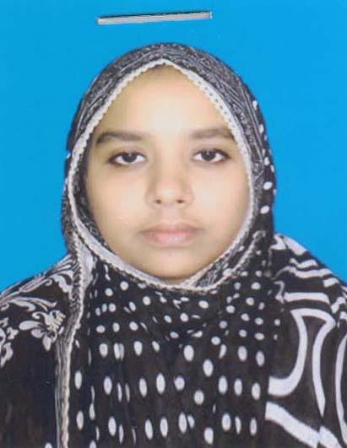 | DR. MT. MASUMA AKTER  F/Name: Md. Abdul Bari  M/Name: Mst. Rawshan Ara  BM & DC Reg. No: 90577  NID: 7336577817  Cell: 01999826188  Address: Bera Pump House Bera, Pabna.  Blood Group: O+
212 | Voter No  LM-5000212 | DR. MD. ATAUR RAHMAN  F/Name: Late Abdul Aziz  M/Name: Rangona Begum  BM & DC Reg. No: 17808  NID:  Cell: 01711260962  Address: Pabna General Hospital.  Blood Group: AB+

